**Problem Solving Process**

**Class 8**

**Lab 8**

|  |
| --- |
| Lab Objectives:Decision making |

# The art of effective decision making

## Selection_021In decision making there is a classic five-step approach that you should find extremely helpful. That does not mean you should follow it blindly in all situations. It is a fairly natural sequence of thought, however, and so even without the formal framework you would tend to follow this mental path.

# Define the objective

## Do you know what you are trying to achieve? You do need to be clear – or as clear as possible – about where you want to get to.

## Otherwise the whole process of decision making is obscured in a cloud. As the proverb says, If you do not know what port you are heading for, any wind is the right wind.

## If you are in doubt about your aim, try writing it down. Leave it for a day or two, if time allows, and then look at it again. You may be able to see at once how it can be sharpened or focused.



# Collect relevant information

## The next skill is concerned with collecting and sifting relevant information. Some of it will be immediately apparent, but other data may be missing. It is a good principle not to make decisions in the absence of critically important information that is not immediately to hand, provided that a planned delay is acceptable.

# Generate feasible options

## Notice the word options rather than alternatives. An alternative is literally one of two courses open. Decision makers who lack skill tend to jump far too quickly to the either–or alternatives.

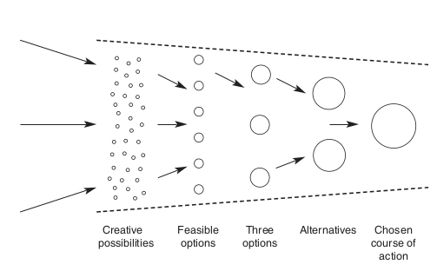

# Make the decision

## The critical preliminary activity here is to establish the selection criteria. It is worth dividing them into different levels of priority. (See the illustration below.) Unless an option meets the MUST requirements you should discard it. But after the essentials have been satisfied, the list of desirables – highly desirable SHOULDs or pleasant addition MIGHTs – comes into play. Choosing a car is a relatively simple case, because there is a finite number of models to choose from and a relatively simple list of criteria. In order to help you choose in more complex cases, remember that you can make a decision by:

## • listing the advantages and disadvantages;

## • examining the consequences of each course;

## • testing the proposed course against the yardstick of

## your aim or objective;

## • weighing the risks against the expected gains.

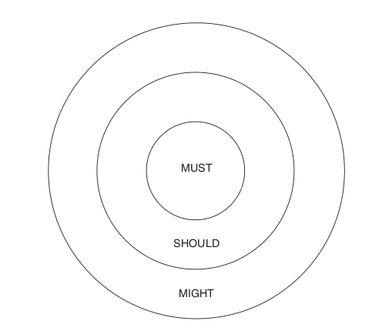

# Implement and evaluate

## Decision comes from a Latin verb meaning ‘to cut off’. It is related to such cutting words as ‘scissors’ and ‘incision’.

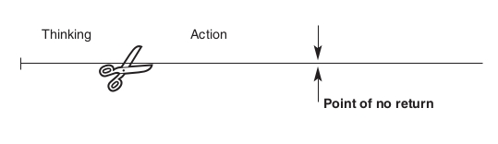

## Let’s have some practical problem solving experiences. Look at the picture very carefully.

# Problem 1

## 

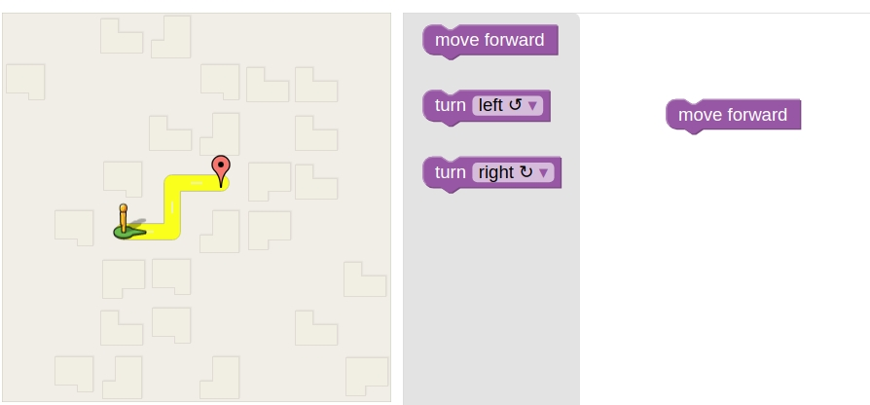

## On the left side there is an object and a destination mark. You have to move the objects to the destination. There are three possible options for you in the middle.

## You have to grab the option on right and make the correct decision to place the objects to the destination.

## Those are the steps to place the object into destination

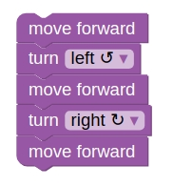

## Have a look

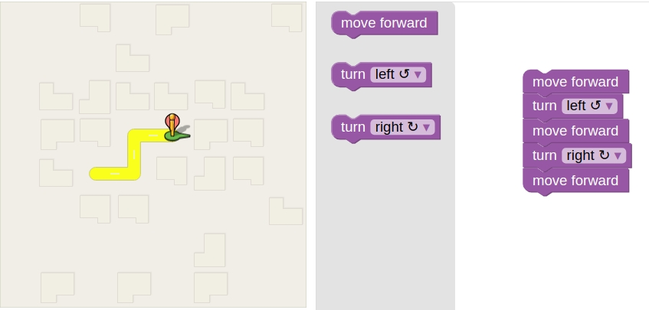

# Problem 2

## There is a bird, a worm and a nest. The bird wants to eat the worm and go to its nest. From its position bird is heading with what degrees to go to its destination?

## Selection_028

## Surely 45 degree is required

## Set heading to 45

## Screenshot from 2018-10-25 14-13-45It can take the worm !!

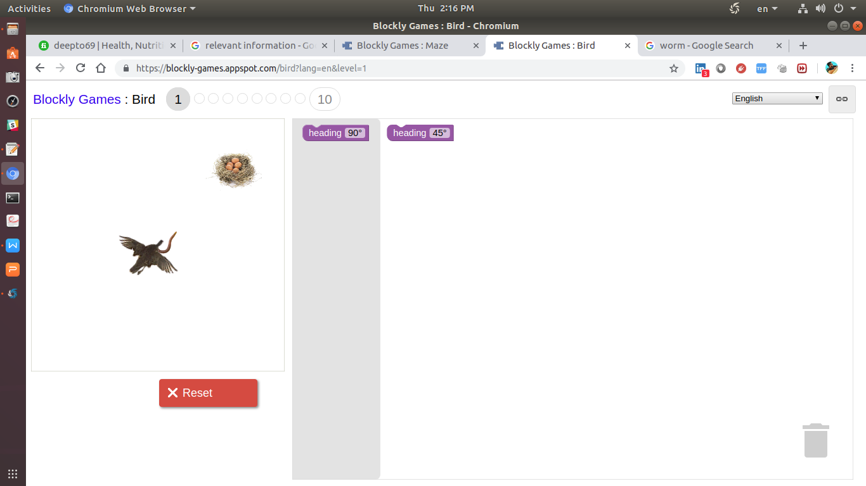

## Screenshot from 2018-10-25 14-16-59It also can go to its nest.